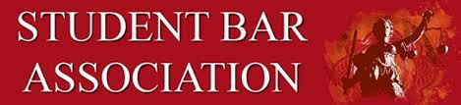**University of Denver Sturm College of Law**

**STUDENT BAR ASSOCIATION**

**AGENDA**

Date: **Monday, September 25th, 2023**

3:00 – 4:00 PM

Rm.125 and on Zoom:

<https://udenver.zoom.us/j/3641068975>

1. **CALL TO ORDER** 
   1. Attendance
      1. Exec: Dévi Stone Chung, Juniper Loomis, Mariah England, Brianna Mendez, Maya Cemper-Walker
2. **GUEST SPEAKERS**
   1. Amber Dannis Updates
3. **PREVIOUS BUSINESS:**
   1. Election results:
      1. Section 1: Michaela McTee
      2. Section 2: Angela George
      3. Section 3: Lilli Warren
4. **COMMITTEE UPDATES**
5. **NEW BUSINESS:**
6. **STUDENT CONCERNS:**
7. **UPCOMING EVENTS CALENDAR**
   1. Fall Festival:
      1. Halloween Tuesday, Oct 3112-2:30pm
      2. Part-time: Special Fall breakfast treats day Oct 22 AM
8. **REMARKS FOR THE GOOD OF THE ORDER**
9. **MOTION TO ADJOURN**